Heritage Statement for:
Flat 14 at
Heathfield Gardens,
Park Road,
Buxton.
High Peak
SK17 6TN

04/03/2021

1-Introduction
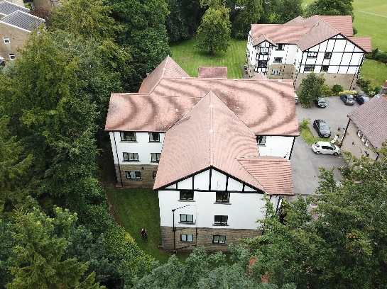
The flats consist of two no. three storey blocks which were built around 1990. There are other Victorian dwellings which were converted into flats at the same time. The site is accessed by a private road off Park Road and is set in secluded grounds. It is not generally visible from the highway or indeed from anywhere else. The site is within the Park conservation area and is under article 4 directive.
2-The Park Conservation Area Character Appraisal
- The main characteristics of Buxton Park are as follows. Large detached and semi-detached villas set within large mature trees and soft planted boundaries
- Level lawns surrounded by planted shrubberies and houses raised up on building platforms.
- Short and gradually unfolding views from the central oval.
- Glimpses of important historic buildings.
Most of the houses are built in natural gritstone in a variety of styles. There are some modern buildings on the western side of the area. There are four listed buildings within the area, one of which is next to the application site.
3-The Application Site
The site is set back off Park Road, adjacent to the oval cricket pitch and is well screened from neighbouring properties by large mature trees and shrubs. There are two modern blocks of flats which been built within the grounds of what used to be a dormitory for pupils of a local private school. The school buildings are built of natural gritstone and are attractively detailed in the style of the Victorian era. They were converted to flats at the same time the new blocks of flats were built. More recently, in 2018, Flat 21, which is part of the older buildings, was given permission to install Upvc windows.
4-The Proposed Works
Over the last 30c years the existing painted timber windows have deteriorated to the point
Page 1 of 2
Heritage Statement for Heathfield Gardens, Park Road, Buxton, High Peak SK17 6TN – David Prior Desgns

that they need replacing. Given the costly 2/3-year cycle of maintenance, the need to reduce the carbon footprint, the need to embrace much high thermal and draft proofing standards, reduce maintenance costs, it was decided to replace the existing windows with high performance Upvc windows which will match the existing in style and colour. It is intended to use Residence R9 which are designed for use in Conservation Areas.
5-Significance of the Historic fabric/area that will be affected.
The principal features of the appraisal are of the spacious settings, mature tree cover and large villas set in a circular style giving short vistas and glimpses of important historic buildings.
6-Impact of the Proposed Works on the Historic fabric/area.
Essentially, the proposal consists of minor works to existing buildings. There is a brief view of the site from the east side of the oval from Park Road but this is at a distance of some 220m. The only minor effect of change will be restricted to the area around the existing buildings with no effect on the wider character of the Conservation Area owing to the mature tree cover.

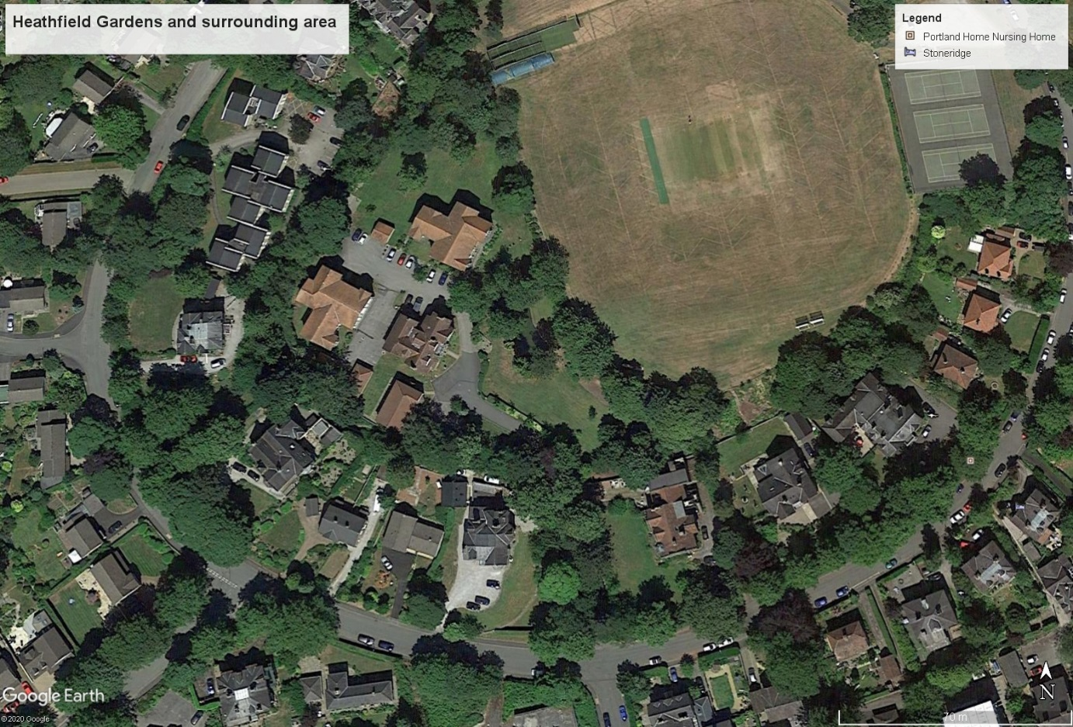

Page 2 of 2

