Design and Access Statement
Replacement of existing timber windows with new Upvc dg.
windows at Flat 14 Heathfield
Gardens, Park Road, Buxton, High Peak. SK17 6TN

04/03/2021

A - DESIGN
A1 - INTRODUCTION
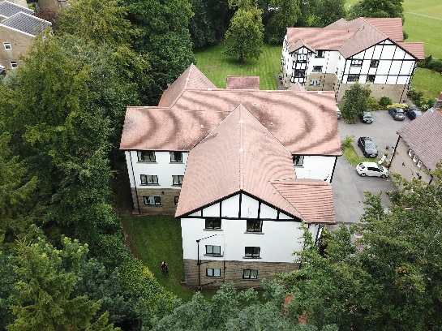
The flats consist of two no. three storey blocks which were built around 1990. There are other Edwardian dwellings which were converted into flats at the same time. The site is accessed by a private road off Park Road and is set in secluded grounds. It is not generally visible from the highway or indeed from anywhere else. The site is within a conservation area and is under article 4 directive.
A2 - USE
Heathfield Gardens is a private residential complex set in landscaped gardens and serviced by a management company.
A3 - AMOUNT
Existing building.
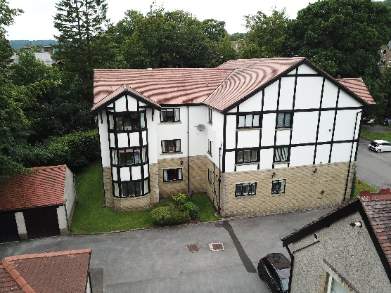
A4 - LAYOUT
Existing building.
A5 – SCALE
Existing building.
A6 - LANDSCAPING
The site is extensively landscaped with large trees and shrubs.
A7 - APPEARANCE
The existing windows are black painted double glazed timber. Flat 21 replaced it’s timber windows in 2018 with dg. Upvc sash windows. Generally, the timber windows are in a poor state of repair and need to be replaced. My clients have chosen to replace them with black coloured double glazed upvc windows of similar design for the following reasons. There will be a thermal gain and an energy saving which is in line with current government policy to reduce energy use and generate less carbon. A reduction in my
Page 1 of 2

client’s energy bills will be welcomed. Upvc windows have improved over the years and now can offer slimmer profiles which can make them undisguisable from timber windows. There will be a year on year saving on maintenance because the 3 to 5 year cycle of repainting will no longer be necessary for those windows replaced. The new windows are intended to look like the existing windows. There will be some minor differences, but overall, the elevations will virtually look the same.
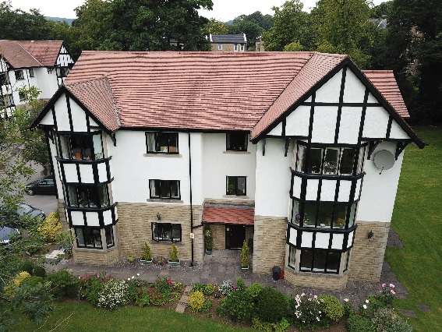
Where the existing windows are fitted in reveal, so will the new ones. Overall, the new windows will be longer lasting than timber windows and offer improved performance. Whilst I appreciate that the property is in a conservation area and under Article 4 directive, it is hidden from public view. Modern upvc. windows are now superior to timber windows in terms of longevity, energy saving and maintenance. I enclose a schedule of addresses where other properties in this area have fitted upvc windows.
B - ACCESS
B1 - VEHICULAR AND TRANSPORT LINKS
The site is close to Buxton town centre where bus, rail and taxi services are available.
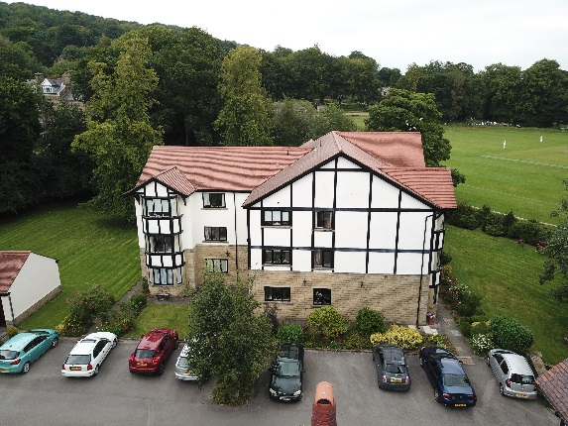
B2 - INCLUSIVE ACCESS
Ramped access is available to the entrances.

David Prior Designs
The Rowans, 7 College Road, Buxton, Derbyshire. SK17 9DZ
Mobile 07976 565 169
Email idrprior@gmail.com

Page 2 of 2

