43 Bennet Street Information

The property address is 43 Bennett Street, Buxton SK17 6NA

We have been asked to apply for a Certificate of Lawfulness to clarify the out come of the meeting with the Planning officers at Buxton Town Hall. The property use was discussed and the Senior Planning officiers and Planning officers concluded that there has been no change of use at the property (Please see email message below which summarises the meeting).

Email from Mr James Stannard, sent as a summary of the Planning Surgery meeting.
Good Morning Steve
Thank you for attending Planning Surgery earlier this morning to discuss an Enforcement Letter received by our Monitoring and Compliance Officer Mr Darling regarding the use of 43 Bennett Street, Buxton as an Air B&B holiday let.
Having discussed the matter further with Mr Darling and a Senior Planning Officer Jane Colley, it is our initial view that there would not be a material change of use and that planning permission would not be required.
However, for clarify and to receive a formal opinion from the council, it would be advisable to submit an Application for a Lawful Development Certificate for an Existing Use with appropriate supporting information.
Such an application should be made via the online Planning Portal.
I would be grateful if you would confirm receipt of this email and understanding of its contents.
Regards
James Stannard MRTPI
Planning Officer
High Peak Borough Council/Staffordshire Moorlands District Council
Tel: 01298 28400 (Ext. 4298)
Mobile:
Email: james.stannard@highpeak.gov.uk

The property is advertised on line for rental as a short term holiday let :
https://www.airbnb.co.uk/rooms/20123482

I have copied the description section (Appendix A) to highlight certain points.
- There is ample on street parking, but to help alleviate issues caused by guests arriving in multiple vehicles I offer off road secure parking at another location within Buxton.
- In the house rules section we are explicit with our No Parties or Events rule.
- We also draw attention to the fact that it is residential road with families and to be conscious of noise levels in the evening.

We have blocked out New Years Eve so that it cannot be booked as even with the No events or parties rule it could be noisier for the neighbours and we would rather lose the income than fall out with them, as they have previously help us find tenants for the property.

We offer discunts to guests for longer stays to try to encourage less changeovers and currently have a 2 night minimum for weekend bookings (taking advice from the on line community about avoiding unsociable behavior).

Where possible, by supplying stairgates, fire guards, high chairs & bed guards we have targeted the house at families with children to attempt a good fit with the surrounding properties.

We have now had a good number of lets and visit the property regularly to check and clean it, we have not had any issues so far. We aim to clean during the day to minimize noise disruption, where this isn’t possible we always at least do the vacuuming before 20:00.

The property was previously rented on an AST and has had Electrical safety, Gas safety and Legionella risk assessments carried out. A mains powered, RF linked smoke detector system is in place and we have a fire extinguisher on the premises.
Current EPC is in place and low energy lighting, energy efficient heating and appliances are installed where feasible.
Hopefully this provides the required information, please contact me if you need more.

Kind Regards

Steve Jackson

Appendix A

Rainbow Terrace - Now with Fibre Broadband.
Entire house · Derbyshire
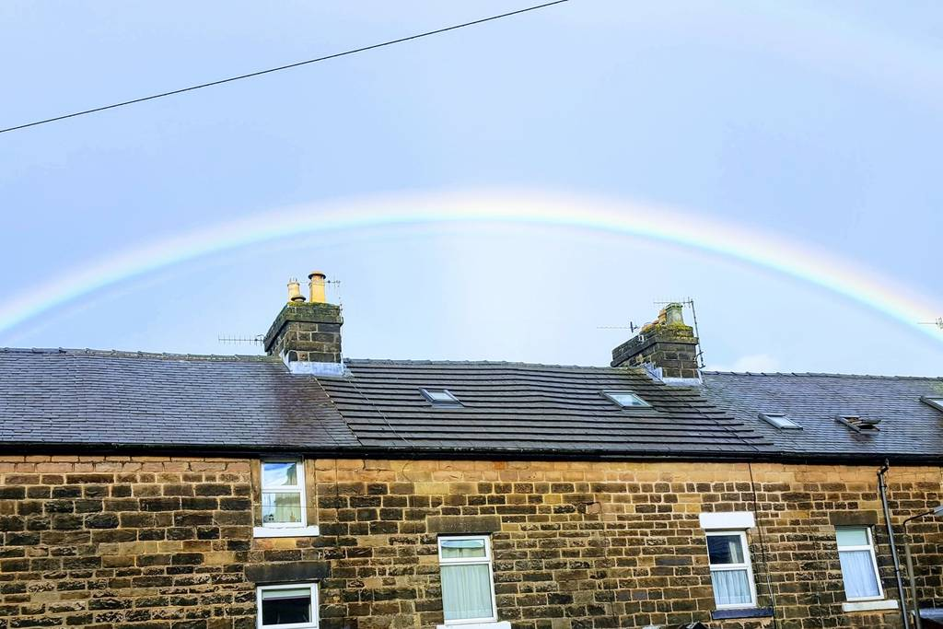
5 guests 3 bedrooms 4 beds 1 bath £53 per night
A comfy, well equipped 3 bedroom (4 Beds) House which is less than 10 mins walk to all of Buxton's attractions. A refreshing alternative to a local bed and breakfast or hotel.
The space
The house has a park a couple of minutes walk from it and the main town centre is less than a 10 minute walk. It is a fresh, light & homely, well equipped house with everything you will need. The house gives you great flexibility and makes a pleasant alternative to all double rooms or a family room in local hotel or bed and breakfast. There is on road parking outside the house with no time restrictions. You are in central Buxton so everything is within walking distance including the fabulous Opera House and the historical Pavilion Gardens. Take a walk down the slopes to see the old Devonshire Dome & spa.
Guest access
You will be booking the whole house which works out considerably cheaper than a family room and twin in local bed and breakfasts or hotels.
Interaction with guests
We live locally and are contactable by phone or email and will try and respond as soon as we can.
The parking is pretty good but if you are arriving in multiple vehicles and have any problems we have secure parking at our home a mile away which you are welcome to make use of.
Other things to note
We have kids and know how much room their stuff can occupy in a car. Let us know what you need, we have travel cots, stair gates, etc. available.
House Rules
No smoking
Not suitable for pets
No parties or events
Check-in is anytime after 4PM
Check out by 10AM
The house is on a residential road with families living around, please keep an eye on noise levels as the night wears on.
You must also acknowledge
Must climb stairs - It's a 3 storey house. The Twin and Bathroom are on the 1st floor, with the Double & Single on the 2nd.

