Martin Prescott
330 Hollins Lane,
Hollins,
Bury,
Lancs.
BL9 8BS

0161 796 6211
07946 488467
mailto:martin.dauby@tiscali.co.uk

Adam Harrison
Harrison Homes
3 Hawthorne Lane
Wilmslow
SK9 1AA
07940 507953
adamlife73@gmail.com

1.3.2016
Mitigation and Biodiversity Enhancement – Development of Land at Paradise Street, Hadfield, Glossop
Consultant- Martin Prescott. (Bat licence no. CLS/01281)

Contents

1. Introduction

2. Habitat Loss

3. Mitigation

4. Habitat Enhancement

1. Introduction

It is proposed to build houses on this site (see plan) and an area of scrub, small trees, ruderal vegetation and improved grassland will be lost.

2. Habitat Loss

The site was predominantly grassland with areas of scrub and scattered small trees.
The grassland had not been grazed or cut for several years and is likely to be rich in invertebrates.

Areas of thorn scrub, small trees and brambles are likely to be used by nesting birds. The site is used by dog walkers and ground nesting birds are unlikely.

There was no significant potential for roosting bats on site, but foraging bats will use the site, especially areas around the periphery to the north where there is woodland trees just outside the site.

Two drystone walls and the remains of a wall provide suitable crevices for use by reptiles. Further work to determine the status of reptiles on site may be required at the appropriate season. Although these walls are outside the present proposed development, reptiles using these feature are likely to forage on the proposed development site and the grassland and scrub provide suitable foraging habitat.

3. Mitigation

It is strongly recommended that where practicable (i.e. on areas not required for hardstanding, roadways, gardens etc), existing trees and scrub are left undisturbed. Trees and scrub to be retained must be given protection measures in accordance with BS 5837:2012.
Some scrub and small trees may have to be removed, but this can be mitigated by the planting of a hedge around the periphery of the site. Suitable areas are marked in green on the plan below. It may not be practical to plant all of these areas. The hedge should be of Hawthorn of locally native provenance. Any tree planting should be of native species, preferably of locally native provenance, such as Crab Apple, Rowan, Bird Cherry and Holly. These have been chosen for their attractive blossom and fruits.

The wall just beyond the south edge of the site (yellow on the plan) must not be directly lit either during construction or in the final development.

It is also recommended that any fences have gaps underneath to allow access for Hedgehogs. This may either be provided by raising fencing panels by 12 cm or cutting a gap about 12x12cm at the bottom of the fencing panels every 5 metres or so.

Further mitigation may be recommended as the result of future reptile surveys.

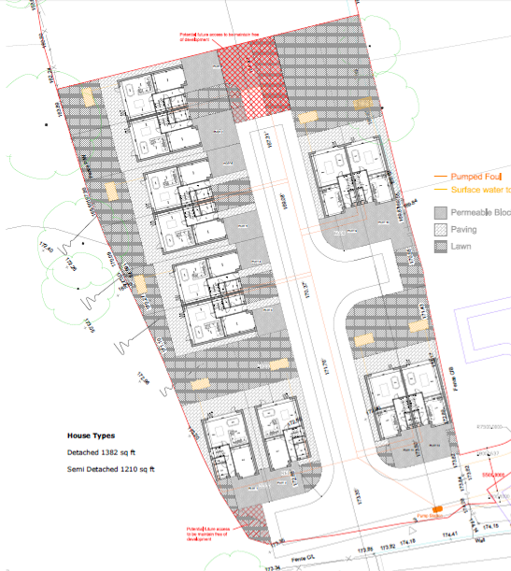

4. Habitat Enhancement

Bird boxes on the houses are recommended.
In particular, nesting sites for House Sparrows and Swifts, (both have declined in recent years) are recommended. Both box styles are easily obtained from commercial ecological suppliers and the RSPB.
Both House Sparrow “terraces” and Swift boxes should be sited under eaves and facing north or north west. They should not be sited over windows or doorways.
The most northerly of each pair of the three proposed semi-detached houses (see plan above) at the west of the site can be fitted with these boxes. Two of each type can be fitted to both north and west aspects of each house, a total of 12 boxes.

In these same houses, access for bats can be provided by the use of “bat tiles” in the roofs as illustrated below. These must be located high on the west facing pitches, one on each house.
As an alternative to the lead panel, purpose designed bat tiles are available.
The roof lining within the area defined by the rafters either side of the “bat tile” and from about 30cm below the tiles as far up as the ridge should be of the traditional bituminous felting. Modern woven felting entangles bats which can result in death of the bat and damage to the lining.

Martin Prescott

