Martin Prescott
330 Hollins Lane,
Hollins,
Bury,
Lancs.
BL9 8BS

0161 796 6211
07946 488467
mailto:martin.dauby@tiscali.co.uk

Adam Harrison
Harrison Homes
3 Hawthorne Lane
Wilmslow
SK9 1AA
07940 507953
adamlife73@gmail.com

29.2.2016
Initial Bat Survey of Land at Paradise Street, Hadfield, Glossop
Surveyor- Martin Prescott. (licence no. CLS/01281)

Contents

1. Introduction

2. Method

3. Results

4. Conclusions

5. Recommendations

6. Photos

7. Plan

Summary

There were no features on site with any significant bat roosting potential.
A drystone wall just outside the site to the north was considered to have low bat roosting potential, but is unlikely to be disturbed.
The probability of birds’ nests in the scrub/brambles on site was considered very high.

1. Introduction

1.1 Reason for Survey

It is proposed to build houses on the southern half (approximately) of this site and an assessment for bat roosting potential was required.

2. Method

2.1 Risk Assessment, Possible Hazards

The required access to the site was easy.
There were no hazards other than those normally encountered when surveying in the field.

2.2 Daylight Survey, 28.2.2016

A walkover survey was carried out over the site and any structures and trees on site or around its borders were assessed for bat roosting potential.

3. Results

3.1 Daylight Survey, see photos and plan

The site was predominantly grassland with areas of scrub and scattered small trees.
The site was off Paradise Street, Hadfield, Glossop.
The map reference of the centre of the site was approximately SJ019963.

3.1.1 The Trees

Trees that were either on the boundary just outside the site were assessed for bat roosting potential. None of these trees were considered to have any significant bat roosting potential, see photos 1-5 and 7.

3.1.2 Structures

A 1.5m high drystone wall on the eastern boundary (photo 6) had many crevices, but the scrub next to the wall would have obstructed any bat access in the summer and the wall was considered to have minimal bat roosting potential.
A 2.5m high drystone wall just outside the site to the south was of similar construction and likely to have low bat roosting potential, however, it is a few metres to the south of the site and it is unlikely to be disturbed.

3.2 Alternative Roosts

There were many dwellings within a few hundred metres which were likely to have high bat roosting potential.

3.3 Possible Bat Foraging Sites

The immediate area consisted of rough grassland, an area of woodland, scattered small and semi-mature trees, scrub, and gardens.
The immediate area was likely to be of high potential for foraging Pipistrelles. Other species are possible.

4. Conclusions

4.1 No trees in or immediately adjacent to the site had any significant bat roosting potential.
The only structure with bat roosting potential, and that only low, was the 2.5m high wall just outside the site to the south. There is no intention to disturb this wall and the risk to roosting bats is considered negligible.

4.2 Birds’ nests were considered likely in the scrub, brambles, trees and dry stone walls in and immediately adjacent to the site.

4.3 The site and immediate area was considered to be of high value for foraging Pipistrelles. Other species such as Brown Long-eared bats and the commoner Myotis species are likely.

5. Recommendations

5.1 Work can commence with extremely low risk to roosting bats, however, it is recommended that the 2.5m high drystone wall just outside the site to the north is not directly lit, either during construction works or by the final development, such as by street lights or security lights.

5.2 If practicable, it is recommended that any scrub, brambles or trees that need to be removed are removed between September and February inclusive when birds are unlikely to be nesting.
In any case care must be taken not to disturb nesting birds and removal of trees, scrub and brambles outside these times must be supervised by a suitably qualified ecologist.
If active nests are encountered, the nest must be left undisturbed until the young have fledged.

5.3 If work has not substantially started by April 2018, a repeat survey is recommended.

5.4 It should be remembered that bats are occasionally found in the most unexpected places. If any bats are found during the work, South Lancashire Bat Group or the consultant, see header, should be notified and work stopped immediately.

6. Photos

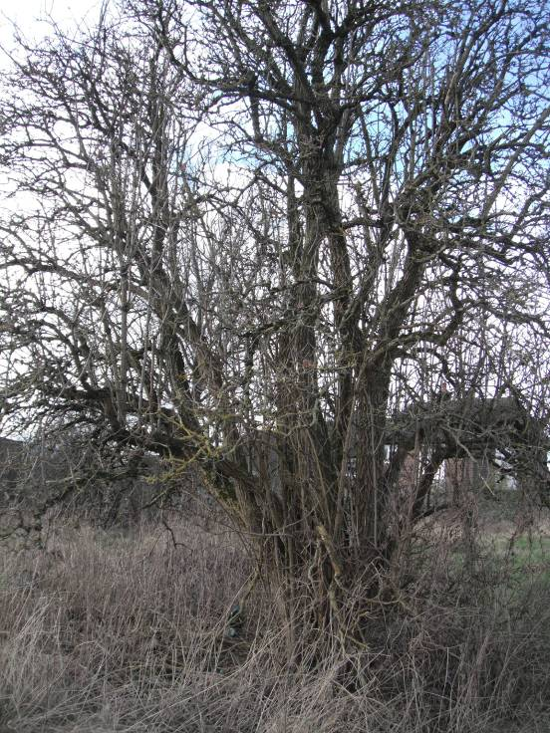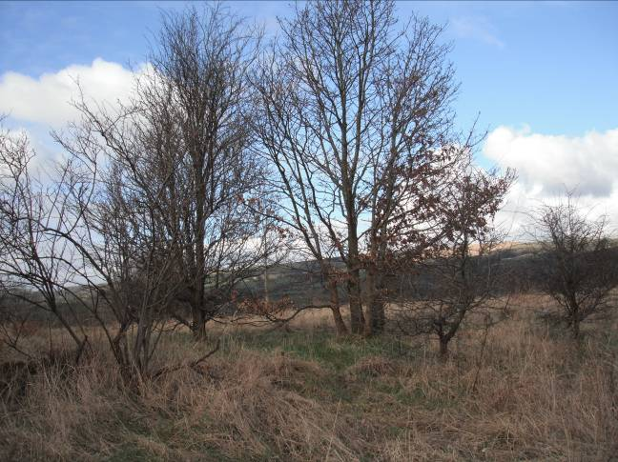
P1 Elder in South-west boundary P2 Small trees, west boundary
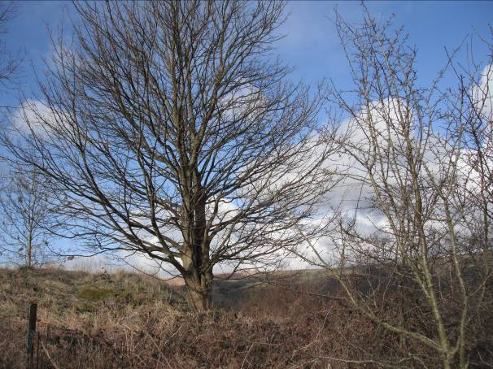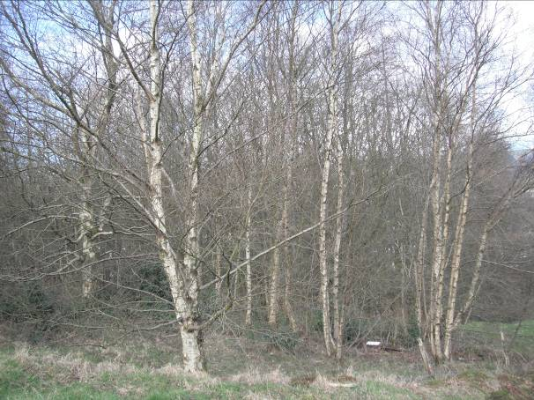
P3 Sycamore outside site to west P4 Birch wood outside site to North-west
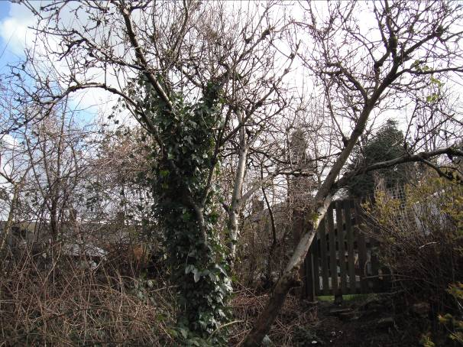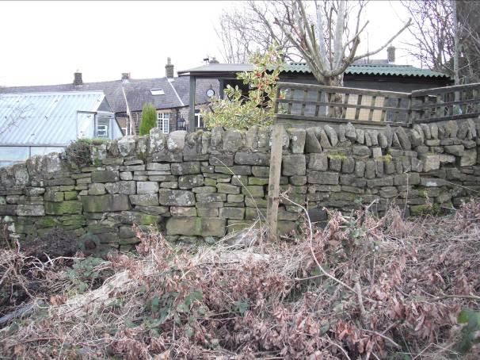
P5 Apple tree with Ivy in North-east corner P6 Dry stone wall, East boundary
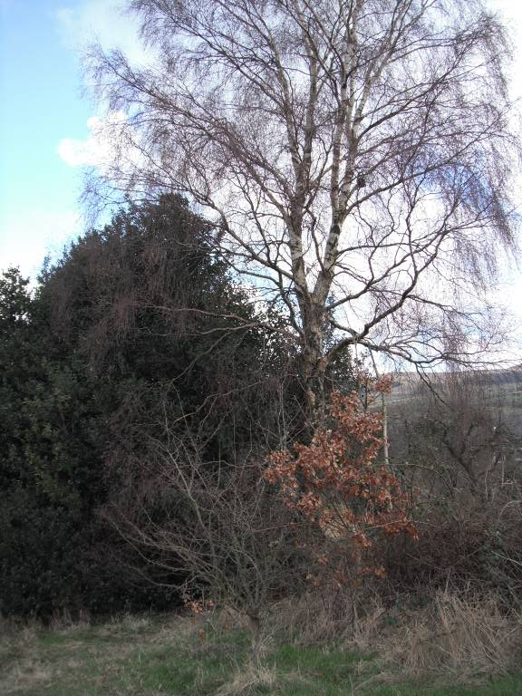
P7 Birch and Holly, east boundary

7. Plans

Not to scale

apple
P5

Birches scrub
P4 Possible future
development
dry stone wall
P6 N

Scattered small trees
brambles

Sycamore P3 Holly
P7 Birch

To be developed
Sycamore under present scheme
P2

patchy scrub and brambles

P1 access
Elder
dry stone wall

P = photos

Martin Prescott

