Design and Access Statement

FOR THE PROPOSED INSTALLATION OF AN EVANCE 5kW WIND TURBINE BY

INVESTMENT RENEWABLES, UNIT 2, 14 WAKEFIELD ROAD, GRANGE MOOR, WAKEFIELD WF4 4DS

FOR AND ON BEHALF OF

MR W ASH, LOWER EAVES FARM, CHAPEL-EN-LE-FRITH HIGH PEAK, DERBYSHIRE SK23 9UA

OUTLINE OF THE PROPSAL

Investment Renewables plan to install an Evance R9000 5kW wind turbine at the above referred site to generate electricity for use by the client for his property/business. The turbine is grid connected and during times of low power use, excess electricity can be fed into the National Grid.

Evance R9000 Wind turbine

Height to nacelle 15.0 metres

Blade Diameter 5.5 metres

Overall height 17.25 metres

Power Generation 9,314 kWh per annum

Based on wind speed 4.8 metres per second

Cut in wind speed 3.0 metres per second

Cut out wind speed None

Survival wind speed 60.0 metres per second (134mph)

Construction Galvanised steel tower with GRP blades and nacelle

A design drawing of the turbine and base fixing detail shall accompany the application, a technical data sheet is available online, and can be viewed here:

http://www.evancewind.com/images/uploads/products/Evance_R9000.pdf

LOCATION

Latitude 53:19:06.17° N

Longitude -1:54:05.82° W

Grid Reference SK 066 801

Local Authority High Peak

Ordnance Survey Site plans shall accompany the application.

Access to the site will be via the B5470 and onto Park Road and will not require any permanent road closures. There may be the unlikely need for the delivery vehicle to slow traffic for a very short time during access to site, but this will be adequately manned and kept to an absolute minimum.
GOVERNMENT POLICY

1.1 Renewable Energy development projects should be capable of being accommodated throughout England in locations where the technology is viable and environmental, economic and social impacts can be addressed satisfactorily.
1.2 The NPPF published on Tuesday 27th March 2012 contains new policy guidance, which is an important and material planning consideration that should be given significant weight when taking decisions.
1.3 The NPPF introduces a presumption in favour of sustainable development, indicating that such development should proceed without delay. The proposed wind turbine at Lower Eaves farm is by definition sustainable development that will benefit the national and local economy and enhance the natural environment.
1.4 The transition to a low carbon future is a core principal of the NPPF and it positively encourages the use and development of renewable energy. It sees this as central to the economic, social and environmental dimensions of sustainable development.
1.5 NPPF also states that, “ when determining planning applications, local planning authorities should recognize that even small-scale development provide a valuable contribution to cutting greenhouse gas emissions; and approve the application if impacts are (or can be made) acceptable” Note: in this case and based on the appeal decision, it is clear that by moving the turbine further away from the noise sensitive receptor, the turbine can now be accepted as the visual impact has not changed.
1.6 In making decisions Local Planning Authorities are required, where the development plan is out of date to grant planning permission unless any adverse impacts of doing so would significantly and demonstrably outweigh benefits, when assessed against policies in the framework taken as a whole. The 12 month ‘transition period’ granted to local planning authorities to up-date their development plans has now expired and full weight must now be given to the NPPF, regardless of the age of the development plan, if there is a degree of inconsistency or conflict.
1.7 The proposed turbine in this particular case is a micro-turbine, which is specifically suited to large domestic properties or smallholdings. The site lies outside the National Park. The turbine has a very small blade diameter of 5.5m and will be mounted on a 15m galvanized column, which will weather down to a dull grey finish once the zinc coating begins to oxidize.
The turbine has been sited as close to the host building as possible but far enough away to provide an acceptable separation distance to the neighbouring property in order to avoid any noise nuisance. It is generally accepted that smaller turbines are suitable if located on settlements, beside farmsteads and in domestic settings.
The new guidance issued following the recent Ministerial Statement by Eric Pickles reminds local authorities that the presumption in favour of wind development shall not override environmental protections and that factors such as turbine scale, topography of the surrounding landscape and cumulative effects are key considerations.
In this case we feel that these factors have been satisfactorily addressed. The turbine sits in a position that is surrounded by rising hills and will not be a prominent feature of the skyline. Given its modest scale, its presence will diminish rapidly with increasing distance and at distances of 500m it will be seen as a very marginal feature in the landscape. At distances beyond 1.5km, it will be very difficult to identify.

LOCAL POLICY
PPS1 Delivering Sustainable Development
PPS1 sets out the Government's overarching planning policies on the delivery of sustainable development through the planning system. This PPS replaces Planning Policy Guidance Note 1, General Policies and Principles, published in February 1997. The document states that planning should facilitate and promote sustainable and inclusive patterns of urban and rural development by:
- Making suitable land available for development in line with economic, social and environmental objectives to improve people's quality of life;
- Contributing to sustainable economic development;
- Protecting and enhancing the natural and historic environment, the quality and character of the countryside, and existing communities;
- Ensuring high quality development through good and inclusive design, and the efficient use of resources; and,
- Ensuring that development supports existing communities and contributes to the creation of safe, sustainable, liveable and mixed communities with good access to jobs and key services for all members of the community.

PPS22 Renewable Energy
This PPS aims to encourage further development of renewable energy resources. It states that all Regional Spatial strategies and local development documents should contain policies designed to promote and encourage the development of renewable energy resources. Planning authorities should set out the criteria that will be applied in assessing applications for planning permission for renewable energy projects.
The Regional Spatial Strategy should include the target for renewable energy capacity in the region, where appropriate this can be disaggregated into subregional targets.
Local planning authorities may include policies in local development documents which require a percentage of the energy to be used in new residential, commercial or industrial developments to come from on-site renewable energy developments.

CERTIFICATION
The Evance R9000 complies with IEC 61400-2 standard for small wind turbine design.
The turbine has CE certification.
The turbine has MCS Certification.
Evance and Investment Renewables are approved as a certified installers.

VISUAL IMPACT

Every effort has been made to site the turbine sensitively and to blend the turbine into the local surroundings and topography.

Wind turbines rely on a clean supply of wind, free of turbulence in order to ensure maximum performance. However, it is critical that the site chosen not only offers efficiency, but minimises visual impact where possible.

The site does not lie within an Area of Outstanding Natural Beauty, Green Belt, or National Park, however, the site is directly adjacent to the High Peak National Park, hence every care has been taken to site the turbine sensitively. In the case of this site, due to the rapid rise of the land to the immediate east, in the direction of the National Park, the turbine is extremely unlikely to be visible from the Park.

It is important to point out that the last attempt to apply for planning saw the turbine refused at appeal, not based on visual impact but based on noise impact, an issue that has now been addressed.

Several other aspects have also been taken into consideration during the proposed siting, namely;

Position relative to hedgerows and trees – the turbine should not be sited within 50m of a hedgerow of tree to minimise the risk to bats, in accordance with Natural England’s Technical Note TIN051.

Location relative to neighbouring properties – we have now repositioned the turbine so it is in excess of the 134m distance that will not exceed a 35dBa above the background noise levels.
All sound pressure levels are LA,90, based on a wind speed of 10m/s at 10m height. This will ensure that the impact on neighbours is kept to a minimum. Additional documents will be added to this application, showing the reduced noise impact and accepted compliance of siting the turbine at the 140m plus distance.

Location relative to public footpaths and highways – the turbine must be sited at least overall height plus 10% in order to maintain safe distance in the unlikely event of collapse.

View from neighbouring properties – Where possible, the turbine will have been sited in a position, which will obscure the turbines view using the sites topography, vegetation and existing structures. The nearest neighbour has a large well established tree row, which masks any full views of the turbine.

Proximity to power lines – YEDL guidance states any turbine should be at least turbine height plus 9m from any overhead cables.

SAFETY
Suitably maintained turbines are safe and offer little in the way of danger to the public. A full servicing and maintenance programme will be provided.
The icing of the blades is not seen as a risk on this site.
The turbine has been sited to ensure no risk from overhead power cables.
The nearest airport is Woodford approximately 25km away.
The nearest railway line is 290m south west, and poses no danger to passing trains.
The distance from the turbine to neighbouring properties ensures that shadow flicker will not pose a risk to the client’s neighbours.

IMAGES FROM THE SITE
The following images form a 360 degree panoramic view from the proposed position of the turbine. Note the steep rising land to the north, northeast, east and southeast, which combined with the extensive tree line to the east running north to south, shall mean zero visibility from the east other than that along the Ashbourne Lane for approximately only 500m.
Note also the significant distances to the west of any visible residential dwellings, and presence of any access from public access routes. The line of trees to the immediate north will obstruct the turbine from view completely to the areas along Beresford Avenue, Brooklands road, Homestead Way, and Thornell Close; the nearest residential streets to the site.
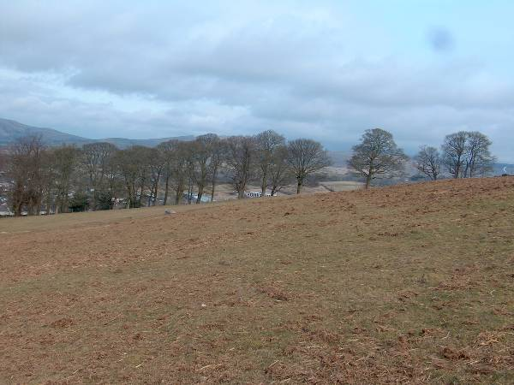  North | 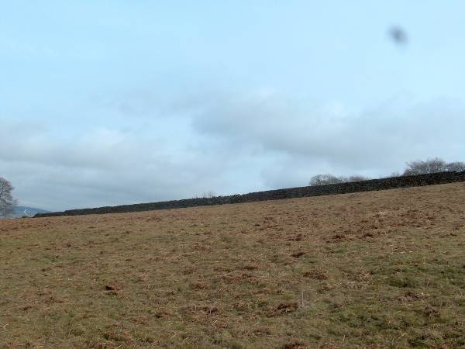  North East
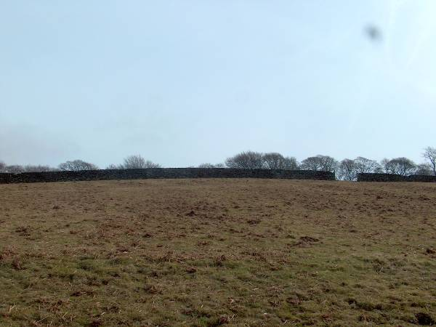  East | 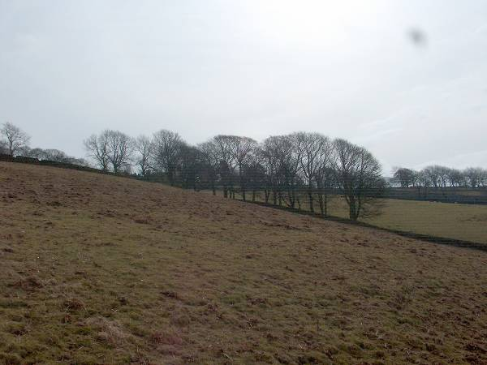  South East
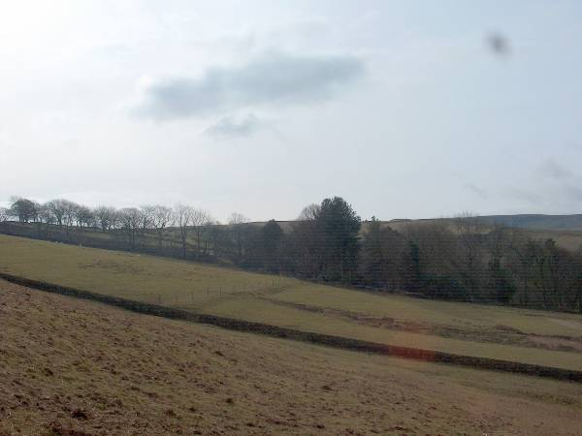  South | 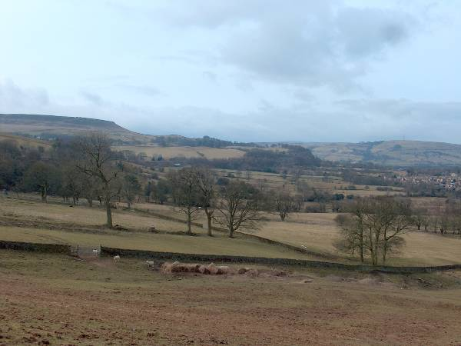  South West
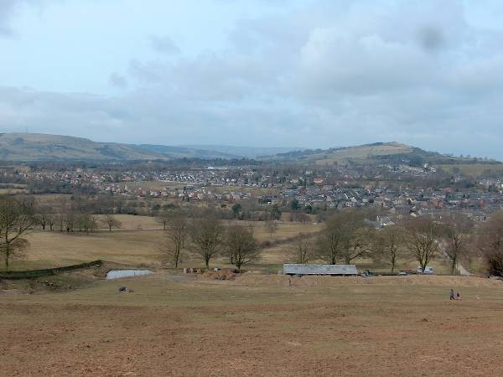  West | 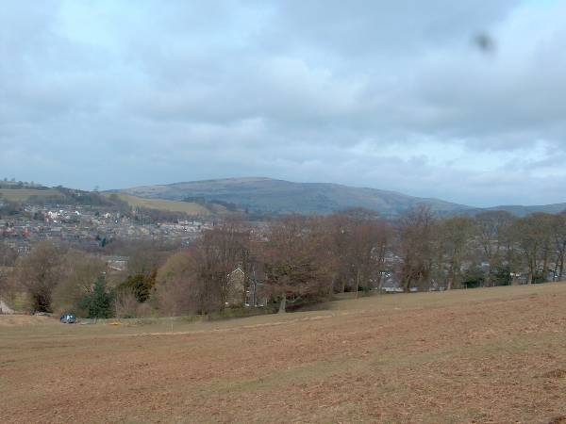  North West
PHOTOMONTAGE
Please see the supporting Visual Impact Assessment detailing the likely visual impact from the surrounding area.
NOISE
Noise generated by wind turbines are gentle “swooshing” noises as the turbine blade passes the mast. It is also possible that as the turbine turns in the wind, this can create a temporary increase in noise from the blades themselves.
There is no scientific evidence that low frequency noise produced by turbines is hazardous to the health of either humans or wildlife.
However noise is subjective, and it is critical due consideration be given to the siting to ensure the turbine does not cause harm to neighbouring properties.
The turbine is 140m plus from the nearest domestic dwelling not owned by the client, and at this distance, the noise generated by the turbine should not be audible. In addition, the turbine shall be sited behind a group of mature trees. The turbine begins operation at 3.0m/s, and at such wind speeds the background noise levels will be increased to mask the noise produced by the turbine.
This new application has taken note of comments made by the inspectorate (MR A Thickett) that visited site on the 3rd July 2013 and has addressed them in full, by siting the turbine well over the 134m required to avoid any unacceptable noise disruption. See document – Ref: APP/H1033/A/13/2192967.
A noise report is supplied with the planning application, showing a more rural location that was passed with the turbine sited at 83m. This is just to provide an example.
Friends of the Earth Cymru constructed a data sheet which includes details regarding noise concerns with wind turbines, which have no scientific base, and can be viewed here:
http://www.foe.co.uk/resource/briefings/wind_myths.pdf

ECOLOGY
The site does not lie within an area of Specific Scientific Interest.
Research by the American Wind and Energy Association has shown turbine blades pose minimal risk to birds, and far less than the risk of static high rise buildings and moving vehicles.
The RSPB state “…the RSPB favours a broad mix of renewables, including solar, wind, and marine power, wherever they are used in ways that minimise unnecessary damage to wildlife and the natural environment. We particularly support solutions that enable individuals and communities to generate their own power close their homes and businesses.”
We take bat safety extremely seriously. Turbines are sited with due consideration to possible bat roosts and foraging grounds, and are sited in accordance with guidelines set out by the Bat Conservation Trust and Natural England. The turbine is well in excess of 50m from any hedge lines.
CONCLUSION
The turbine will provide renewable energy for the client for a minimum period of 20 years, with negligible impact, and will assist with the councils efforts to attain Government targets on renewable energy generation. We have addressed all issues reported in the dismissed appeal and can’t see any reasons why the local authority wouldn’t be able to support this application in full.

