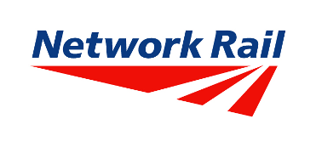

HERITAGE STATEMENT

Repair and refurbishment works:
Glossop Railway Station, Glossop

Introduction

This statement gives an outline of the principles adopted by the proposal in context to the heritage status of the application site.

Glossop railway station is a Grade II listed building, designated in December 1958.

The application seeks listed building consent for the repair and refurbishment of Glossop railway station. A separate planning application is not required in this instance as the proposed works either fall under permitted development (Part 17) or do not constitute development.

Site Context

Glossop station lies towards the centre of Glossop, within the defined town centre limits for the settlement as defined on the High Peak Local Plan proposals map. The site consists of a Grade II listed building (station) and falls within the designated Norfolk Square Conservation Area.

The station is one of two termini on this line, the other being Hatfield. Glossop station lies on the Glossop to Dinting West Junction Curve Branch line which was originally a branch line off the Manchester to Sheffield line. The station currently consists of 1 platform, the station building and associated car park provision and is attached to a Co-op supermarket and parking.

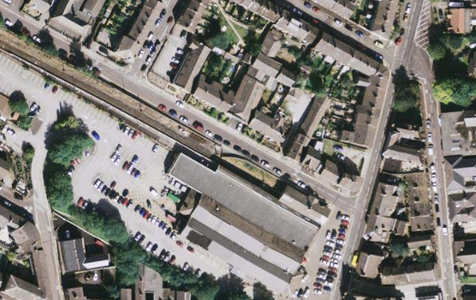
Aerial view of Glossop station & Co-op buildings.

The station falls within an area consisting of mixed commercial and leisure facilities and residential properties.

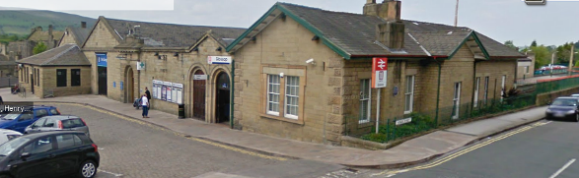
Norfolk Street and Howard Street station elevations.

Heritage Context

Glossop railway station was designated as a Grade II listed structure in December 1958.

The station was originally built in 1847 for Henry Howard, the 13th Duke of Norfolk, who brought the Sheffield and Manchester Railway line from Dinting to Glossop in 1845. The Manchester to Sheffield line was built in the early 1840’s but the route chose to bypass Glossop and went through Dinting to Hadfield and the Woodhead tunnel.

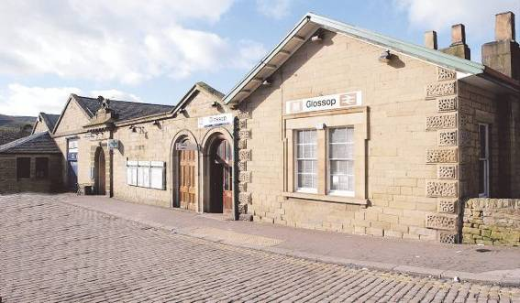
Glossop station frontage

The station complex originally consisted of multiple platforms, the station building and former engine sheds. The station was designed by M E Hadfield and T G Weightman and consisted of a single storey building, constructed of Millstone grit ashlar to end walls, coursed rubble to sides with vermiculated quoins, under a welsh slate and synthetic tile roof. The main entrance door to the Norfolk Street elevation is off centre, with a pediment above surmounted by a stone lion. The lion is the emblem of the Howards, the Dukes of Norfolk.

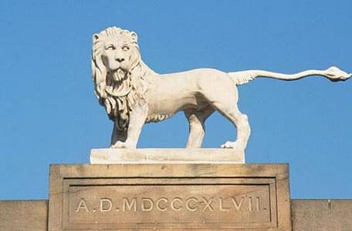
Howards stone lion above entrance doorway at Glossop station.

The English Heritage listed description describes the station as:
4 parallel ranges, pair to left former engine sheds linked to station and offices range by curtain wall with entrance. EXTERIOR: single storey. Norfolk Street front asymmetrical. Former sheds have pedimented gables with coping, rusticated and vermiculated quoins to left and projecting single storey block with hipped roof, 5 blind windows and off-centre doorway. To right large C20 access doorway. Main, central entrance to station has banded and vermiculated rustication, round headed archway surmounted by entablature supporting large carved lion statant with date in Roman numerals. Plain curtain wall links with office which has paired round headed doorways in recessed panel surrounds. Station block has deeply overhanging eaves with rusticated and vermiculated quoins, 2 glazing bar sashes in single moulded ashlar surround. Left return has 11-window range divided by pilasters, with round headed windows, some bays broken through in C20. Right return has 7-window range with overhanging eaves sill band and cornice. Third window bay gabled. Windows have margin light glazing.

In the 1980’s the station was reduced to one platform and the redundant engine sheds and station buildings were incorporated into an extension for the adjacent Co-op and car park.
Proposal

The proposed work at Glossop station relates to repair and maintenance works to the station building and platform. The works involve a combination of elements, some of which do not require listed building consent, whilst other elements do.

Discussions have been undertaken with the Council’s Conservation Officer, who is acceptable in principle over the scheme and has provided guidance on the proposed maintenance works. The Friends of Glossop Station (FOGS) have been consulted as part of the scheme and an information drop has taken place for residents.

The proposed repair and maintenance work at Glossop station includes:
- Renewal of the platform surface (Marshalls charcoal keyblock paving, natural coloured tactiles and concrete copers)
- new and repair drainage (ACO channels and cast iron rainwater goods (RWG’s)
- Repair and overhaul of the canopy (replaced battons, reslate using existing and matching slates where required
- Install Ionsdale skyguard 50 patent glazing to rooflights
- Install/renew canopy and platform lighting
- Repoint platform wall
- Renew station entrance door
- Replace UPVC window with timber sash on Howard Street
- Repainting canopy (match existing)

POLICY ASSESSMENT

The relevant planning policy document for the areas includes the adopted High Peak Local Plan. Policies CS6 and CS17 of the Core Strategy provide guidance relating to the protection of listed buildings and the historic environment, they provide support for works to secure the retention, repair and maintenance of a listed building.

These policies should be read in conjunction with the relevant National Planning Policy Statements, PPS1 ‘Delivering Sustainable development’ and PPS5 ‘Planning for the historic environment’. As well as the Glossop Vision Masterplan and the Glossopdale Townscape Heritage Initiative.

Network Rail understands the importance of approaching these works with care, to ensure that any proposed works at the station do not detract from its listing.

The guidance set out in PPS5: HE7.4 states that when determining applications effecting heritage assets Local Planning Authorities should take into account the desirability of sustaining and enhancing the significance of heritage assets, and of utilising their positive role in place shaping; and the positive contribution that conservation of heritage assets and the historic environment can make to the establishment and maintenance of sustainable communities and economic vitality.

Policy HE7.2 states that in considering the impact of a proposal on any heritage asset, Local Planning Authorities should take into account the particular nature of the significance of the heritage asset and the value that it holds for this and future generations. This understanding should be used by the Local Planning Authority to avoid or minimise conflict between the heritage asset’s conservation and any aspect of the proposals.

Policy HE10.1 states that when considering applications for development that affect the setting of a heritage asset, the local planning authorities should treat favourably applications that preserve those elements of the setting that make a positive contribution to or better reveal the significance of the asset.

The above policies place significance on both preserving and enhancing heritage assets and ensuring that future work will not be detrimental to the significance of the listed building or the character of Conservation Area.

The area around the station has received improvement and regeneration, creating a new public realm. The Townscape Heritage Initiative highlighted the station and immediate vicinity as an area in need of improvement. As part of the Governments Liveability drive to improve towns and cities, Glossop was granted funding inline with the Glossop Vision Masterplan and Implementation Strategy. This has resulted in significant improvements around the town along with key improvements to key public spaces.

The station building is considered to contribute to this regeneration and plays an important part in everyday life. The proposed work intends to renovate and improve the station and in turn will contribute to key improvements that have already taken place.

It is considered that the improvements to the station will enhance the historic character of the existing building, whilst aiming to retain as much of the existing as possible. Through discussions with the Conservation Officer, a lead alternative will be used during the renovation. Due to the previous thefts of lead from the building and that lead proves to be high valuable, Icopal Decra Form Flash will be used in its place. Icopal Decra form flash is a contemporary alternative to lead for waterproof roof flashings, which is lighter, cheaper and environmentally friendly. In addition, it is easier to handle and form and quicker to install, and because it does not have the re-sale value of its predecessor, it is less attractive to potential thieves.

The canopy and platform renovation will enhance the character of the building and will encourage its continued use within the local community for future generations. The repointing works and renewed doors and windows will improve the aesthetics of the building, and will reflect the regeneration works undertaken under The Glossop Plan within the surrounding area.

CONCLUSION

The proposal considers national and local planning legislation to provide a suitable justification for the internal and external alterations to the station building. The proposed changes will promote the continued active use of the station, whilst retaining its historic context.

Taking into account the above policy guidance and the assessment of the proposed work above it is considered that the works would not significantly detract from the historic character or significance of the Listed Building.

It is therefore considered that this application should represent an acceptable proposal in terms of design, access and impact on the heritage assets.

